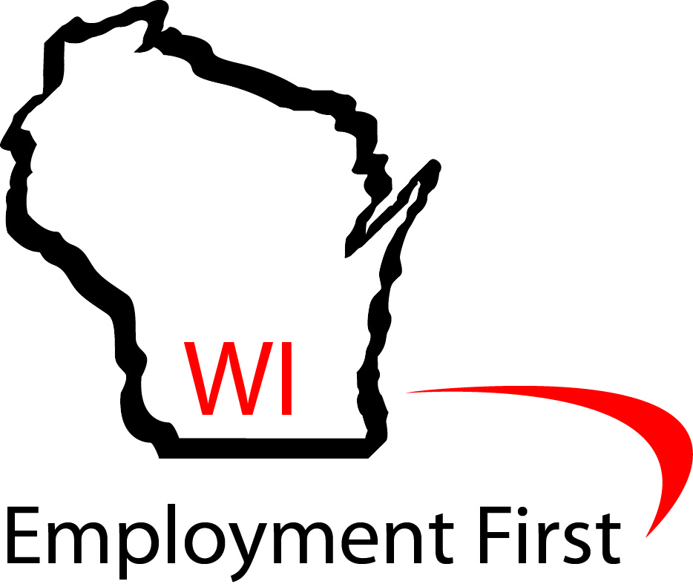 | Wisconsin Employment First  A Path to a “Better Bottom Line”

As a member of the Employment First Coalition, I commit to meeting with my local Senator and Assembly person during the month of October in support of National Disability Employment Awareness
Month. Click here http://legis.wisconsin.gov/ to find your legislators!

 | Name: | Phone Number: | Visit Date/Time:
Senator:
Assembly Person:

Tips for talking to your legislator:

- Be Personal—tell them a little about yourself—make sure they know you are from their district
- Provide data- provide one piece of data that supports your view
- Be focused- remember, they do not have a lot of time so stay on topic
- Be positive-don’t be argumentative. Remember you goal is to develop a long-term relationship
- Make the ask- don’t leave without asking them to support your issue
- End the meeting-don’t stay too long. Thank them for their time and attention
- Follow-up—send a thank you note and restate your main points

