WorkLink’s Scatterplots
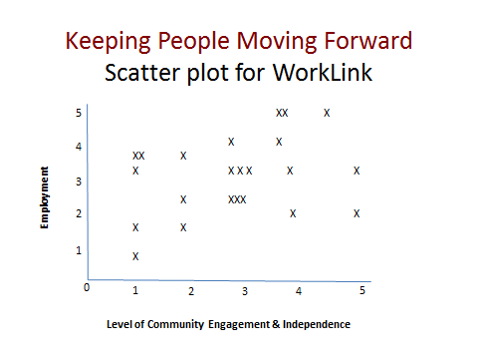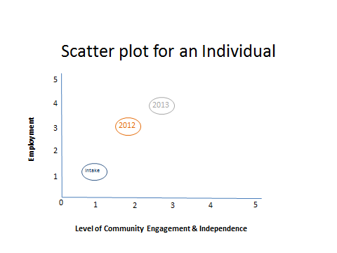
WHAT IS THIS?
WorkLink uses scatterplot graphs to visually represent the progress of people enrolled in our program, on an individual and programmatic level. The point of the scatterplot is not to show a correlation between employment and community engagement- but to plot two measures of success on one graph for the people we serve.
WHY DO THIS?
The goal of our program is to assist individuals with disabilities to become active, contributing members of the community. We use these graphs to evaluate our services and as a way to gage a person’s annual individual growth.
Each year, prior to annual planning meetings, we look at an individual’s “levels” to summarize the progress made on employment and engagement. We use a Community Skills Assessment tool to determine a person’s level of community engagement and independence. The tool rates a person’s hard and soft skills across a number of domains. The average score is graphed as the person’s level of engagement and independence. The individual plots his/her progress on a personal graph and brings it to the meeting to share with others. In addition to painting a big picture, the Community Skills Assessment also helps us to identify areas where the person continues to need support and services. We can then focus on these areas of need and can develop more meaningful service plans.
WorkLink has found this visual representation of progress to be very motivating for both the individuals and our program staff.

