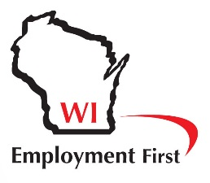
Wisconsin Employment First
Questions and Answers

What IS Employment First?
- A national movement that is helping states improve their economies by supporting businesses to find talent and meet their needs by hiring people with disabilities.
- The intentional creation of policies and practices that result in a significant increase in the numbers of people with disabilities being employed in the community.
- A policy initiative that promotes employment in the community at minimum wage or higher as the preferred outcome for publicly funded services for all working age citizens with disabilities.

What Employment First IS NOT.
- It is not an effort focused on closing community rehabilitation providers (CRPs). It is an effort to create more opportunities for people with disabilities to work in the community earning at least minimum wage. CRPs play an important role in making this happen.
- It is not forcing people with disabilities who want to stay in CRPs to leave and work in the community. It is about making sure that every person with a disability knows that community employment is an option for them, and that they have the opportunities to learn about and experience working in the community.
- It is not taking choice away from people with disabilities and families. It is about providing more, better and different employment opportunities and choices for people with disabilities in Wisconsin.

Why did the Employment First Movement Start?
- Extremely low numbers of people with disabilities working in community jobs earning at least minimum wage.
- Two decades showing declining numbers of people with disabilities working in the community.
- Recognition by disability advocates, self-advocates and families that we were losing instead of gaining ground on employment, and that strong action was needed to reverse this trend.
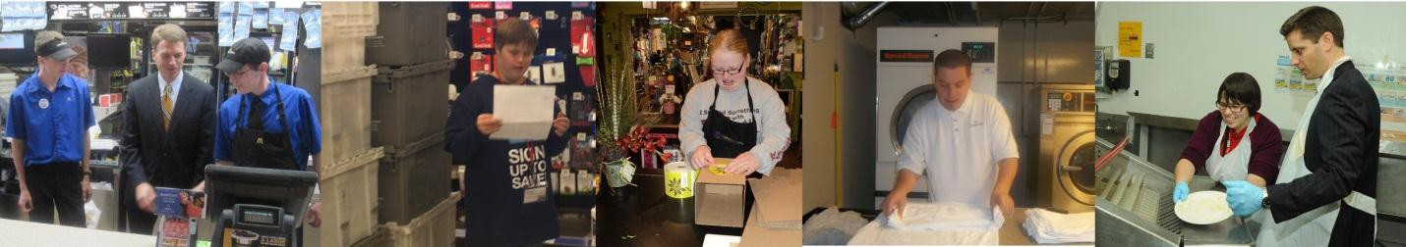

- Need to raise expectations and implement better practices that support and encourage people with disabilities to pursue and realize their employment goal.
- Need for changes in state policy and public funding priorities in order to expand resources available to increase the number of people with disabilities working in the community.
- Need to use public resources more efficiently by investing in strategies that are proven to be effective in increasing the numbers of people in community employment

Is Employment First a philosophy, or is it action?
- Both!
- At the core of Employment First is the belief that everyone can and should have the opportunity to work in the community.
- The Employment First effort involves action at many different levels, including grassroots, policy, and legislation, that are designed to dramatically increase the numbers of people with disabilities working in the community.

What is Employment First doing to increase the number of people with disabilities in community employment?
- Raising public awareness of the possibilities and benefits of employment for people with disabilities.
- Supporting individuals with disabilities and their family members to understand that employment in the community earning at least minimum wage is an option for everyone.
- Raising awareness of the business community about the many ways that hiring people with disabilities makes good business sense.
- Advocating for legislation and state policy that support Employment First principles and practices, including setting targets and providing sufficient resources to significantly increase the numbers of people with disabilities in community employment.
- Developing strong grassroots efforts designed to promote and implement changes that support Employment First at the local level.

Why should Wisconsin be an Employment First State?
- Currently, less than 10% of working-age individuals with intellectual and developmental disabilities in Wisconsin’s long-term care system are in community employment.
- We can and must do better. Other states that are focused on Employment First are achieving integrated employment rates as high as 70%.
- The states with the highest community employment rates have set clear goals and developed the policies and practices necessary to achieve these goals.

Who can be involved in the Employment First Movement?
- Anyone who believes in the basic principles and practices of Employment First and wants to participate in a movement to increase community employment opportunities for people with disabilities.
- Anyone who believes that the current number of people with disabilities living in poverty is unacceptable and that we can do better.
- Everyone has a role to play: individuals with disabilities, family members, businesses, chambers of commerce, legislators, educators, disability service providers, state agencies, foundations, community organizations, and advocacy organizations.

Is this something that is just happening in Wisconsin?
- Absolutely not! Employment First is a fast growing national movement.
- Nearly all 50 states have active Employment First initiatives. Many national organizations including the National Council on Disability, the US Business Leadership Network, the Autistic Self-Advocacy Network, the National Association of Councils on Developmental Disabilities, APSE, and the National Disability Rights Network have endorsed Employment First.
- In Wisconsin, Wisconsin Manufacturing and Commerce along with a growing list of Wisconsin businesses are endorsing Employment First.
- At the federal level, both the US Department of Labor Office on Disability Employment Policy and the Administration for Intellectual and Developmental Disabilities are making resources and technical assistance available to states interested in advancing Employment First.
- State legislatures in California, Kansas and Delaware have enacted Employment First legislation. Other states, including Arkansas, Ohio, Tennessee and Oklahoma have issued Employment First executive orders.

What is happening with the Employment First Movement in Wisconsin?
- In March 2018 the Employment First bill was signed into law!
- State agencies are collaborating to develop and implement a plan to make competitive integrated employment the priority for services for people with disabilities.
- Mini-grants are provided annually through the Wisconsin Board for People with Developmental Disabilities to communities across Wisconsin to raise awareness about Employment First at the local level.
- Numerous outreach and informational tools are being developed to ensure everyone understands what Employment First is all about and why it is so important for Wisconsin.
- Many Employment First events are happening, as well as a statewide Employment First conference.
- A group is working with key policy makers to review state law and policy in order to identify how both could be more supportive of Employment First principles and practices.

Where can I learn more?
BPDD - http://www.wi-bpdd.org/ Wisconsin APSE - http://www.wiapse.org/ National APSE - http://www.apse.org/
People First Wisconsin – http://www.peoplefirstwi.org
Office of Disability and Employment Policy (ODEP) - http://www.dol.gov/odep/topics/EmploymentFirst.htm
Employment First Resource List - http://www.apse.org/employmentfirst/resources.cfm
What Can You Do? Employment First Campaign Public Service Announcement - http://www.whatcanyoudocampaign.org/
WI Let’s Get to Work Project – http:// www.letsgettoworkwi.org

