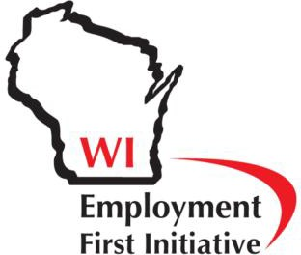
Employment First Wisconsin

An Overview for Educators

Employment First is a national movement that is helping students with disabilities prepare for employment while also helping states improve their economies by putting more people with disabilities to work in the community.

What does Employment First Mean?
- Real Jobs for All: Youth and young adults of all abilities should have the opportunity to work in the community.
- Movement out of Poverty: Too often disability equals poverty. When people with disabilities work, they can increase their income with the goal of moving out of poverty, becoming taxpayers, and decreasing their reliance on public benefits. Regardless of the benefits people receive, they are better off financially if they work.
- Employment in the Community at Minimum Wage or Higher: Policies should be put into place that facilitate and support employment in the community with typical wages as the preferred outcome for publicly funded services for all working age citizens with disabilities.
- Investing Resources for Inclusive Communities: Public resources to assist individuals with disabilities should be spent on services and supports within integrated settings. This includes employment at businesses and organizations in the community that yields benefits to individuals, is more cost effective and creates a better return on investment.
- Providing Necessary Resources for Employment Success: Resource must be available to support individuals with disabilities to find, keep, and advance in their employment through collaboration with organizations, businesses and community members.
- Promotion of Employment in Public and Private Businesses: Both federal and state government should serve as model employers for people with disabilities, setting an example, while also undertaking efforts to promote employment within private industry.
- Protection of Disability Rights: The advancement of rights of people with disabilities resulting from the Americans with Disabilities Act, Olmstead Decision, the Rehabilitation Act, and similar legislation, must be protected and fully enforced.

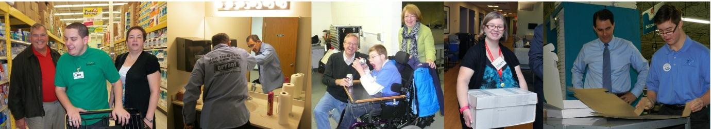

What does Employment First Mean for Committed Educators?
- Preparing youth for integrated jobs and careers in the community by providing opportunities early and often for students to learn about and experience a range of employment options in a variety of community businesses.
- Applying evidence-based transition practices to achieve the most integrated outcomes possible, including: 1) an emphasis on the goal of integrated employment, 2) inclusive high school and college experiences, 3) various work experiences during high school, 4) ongoing discussion with students and their support teams about individualized employment goals, and 5) ongoing collaboration with students, their families, other professionals, and employers to help make 1-4 above happen for each student.
- Utilize instructional methods, such as task analysis and systematic instruction to foster the highest possible level of independence at jobs for students, regardless of disability.
- Transitioning youth to the adult service system with a young adult career goal and a set of direct experiences that have led to the development of that goal. This is also the best way to help students learn soft skills needed for employment success.
- Maintain clear information about the process of career exploration and employment experiences for students so that transition to adult services can go smoothly.

Who are some of Our Employment First Partners?
Employment First is a national initiative that Wisconsin has joined. Nearly every state is active in the Employment First movement – some with legislation and state policies, including Wisconsin. The list of official Employment First backers is growing every day and now includes: the National Governor’s Association, the National Council on Disability, APSE, TASH, and ODEP. Numerous organizations right here in Wisconsin have also signed on to supporting Employment First. Just some of those you might recognize are:
- Wisconsin Manufacturers and Commerce
- Disability Rights Wisconsin
- Wisconsin Board for People with Developmental Disabilities
- People First Wisconsin
- Wisconsin Coalition of Independent Living Centers
- In Control Wisconsin
- Survival Coalition of Wisconsin Disability Organizations
- WI APSE: the Association of People Supporting Employment First
- The Management Group Inc.
- Wisconsin Youth First
- Wisconsin FACETS

